Declaration of Compliance (DoC) for Food Contact Materials

1. Supplier Information
Company name: Bio Degradable Packaging BV
Address: Galgestraat 157, 9700 Oudenaarde , Belgium
Contact person: Alex Gallez
Position: Sales
Email / Phone: sales@biodp.eu
I am …. (tick as applicable) of the products as mentioned under2:
Importer

All information given in this document is solely destined for products supplied to Biodegradable Packaging, based in Belgium.

2. Product Information
Trade name / product code as mentioned on delivery note: paper food trays/paper cake boxes/paper hamburger boxes/waffle tray
Material type:
Paper / Board
- Plastic (covered by EU Regulation 10/2011)
Combination of paper/board and plastic
- Other: ____________________________

The abovementioned material is printed / unprinted (delete what is unapplicable).
Description of material/article: kraft paper/white paper
- The abovementioned material contains post-industrial recyclate (if so: please mention percentage: _____________________%)
- The abovementioned material contains post-consumer recyclate (if so: please mention percentage: _____________________%)
The abovementioned material does not contain recyclate.
Thickness / grammage (if applicable): _____________________
Composition of the layers: paper only
Picture (please insert): ____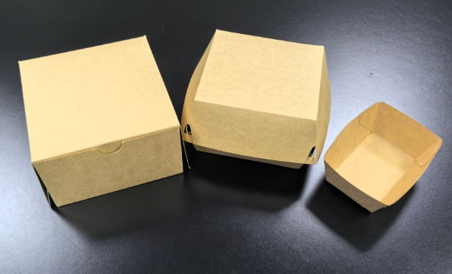_________________

3. Regulatory Compliance
We confirm that we comply with (tick as applicable):
Framework Regulation (EC) No 1935/2004
Good Manufacturing Practice Regulation (EC) No 2023/2006
Regulation (EU) No 10/2011 (only for plastics)
Belgian Royal Decree of 11th of May 1992 (only for paper / board)
We confirm that the materials do not contain substances whose genotoxicity has not been ruled out, and which originate from an intentional use during a manufacturing stage of that intermediate material and which could be present in an amount that foreseeably gives rise to a migration from the final material exceeding 0.00015 mg/kg food or food simulant.
Only if recycled material is used (see section 2.):
- We confirm that we comply with EU Regulation 2022/1616.
Only for printed / coated materials (see section 2.):
All printing inks and related products are formulated in accordance with the EuPIA Exclusion Policy for printing inks and related products. The EuPIA Exclusion Policy states that by default raw materials must not be used in inks, which are classified as toxic or CMR (to be exact: acutely toxic cat. 1, 2 or 3; carcinogenic, mutagenic or toxic to reproduction (CMR) cat. 1A or 1B; or specific target organ toxicity (STOT) cat. 1).

4. Substances and Restrictions
For plastic materials (as regulated by EU Regulation 10/2011):
Contains only substances authorized in EU Regulation 10/2011
Specific migration limits (SMLs) respected: please list all substances present:
- ____________________________

Overall migration limits (OMLs) respected
Dual-use additives declared (where applicable) (i.e. substances with restrictions from Annex I or II of EU Regulation 10/2011: please list all substances present: ____________________________

For paper/board containing material:
Complies with Article 3 of 1935/2004 (no risk to health, composition, or quality of food) Belgian Royal Decree of 11th of May 1992
The abovementioned material does not contain any of the following substances:
- Any Allergens as detailed in the WHO list.
- Azodicarbonamides
- Benzophenone
- Bisphenol A
- Bisphenol S ( BPS )
- Cochineal Extract
- Dioxins
- Ethyl alcohol ( Ethanol / Cas no. 64-17-5 )
- GMO’s Plasticizers / Phtalates
- Hexabromocyclododecane ( HBCDD )
- Hydroxybenzophenone
- ParabensAlkylphenols
- PerAcetic Acid
- Perfluoroctanic acid
- Phthalates
- Polycyclic Aromatic Hydrocarbons
- Polyvinyl Chloride ( PVC )
- 4.4 –Diaminodiphenylmethane ( MDA )
- 4-Methylbenzophenone ( 4MeBP )
- Lead or cadmium
- Latex
- MOSH/MOAH
- Ozone depleting chemicals
- Primary Aromatic Amines
- PFOS / PFAS
- Epoxy derivatives as defined per Regulation (EC) 1895/2005
- Presumed or suspected endocrine disrupters not exceeding 0.1% by mass (AGEC Law no. 2020-105 article 13. II version of 17Apr2023)
In addition to the above absence declaration, we declare that all our products comply with:
- Regulation EC 1907/2006 (REACH), including the latest amendments and the SVHC and Candidate list (latest amendment)
- Proposition 65 of the state of California regarding the Safe Drinking Water & Toxic Enforcement Act.

5. Conditions of Use
Food categories intended for contact (tick all that apply):
Aqueous foods (pH > 4.5)
- Acidic foods (pH ≤ 4.5)
- Alcoholic foods (>10% ethanol)
Fatty foods
Dry foods
Contact conditions (tick all that apply):
Long-term storage at room temperature
- Refrigerated / frozen storage
Hot-fill (up to 100 °C)
- Microwave heating
- Oven use
Contact time / temperature (if specific): food contact at temperatures from 0°C to 100°C for 30mins -1 hour
Food contact surface-to-volume ratio (if relevant): ______________

6. Testing and Supporting Documentation
Migration testing carried out with appropriate food simulants: please add test report (the ratio of food contact surface area to volume used in overall migration testing to determine the compliance of the sample is 10.0 dm²/kg )
- Supporting test reports available upon request
- Worst-case calculation / modelling performed (if applicable)

7. Validity and Traceability
This DoC is valid for the product under the conditions described.
The supplier commits to inform downstream users/customers in case of changes that affect compliance.
Traceability is ensured according to Article 17 of Regulation (EC) No 1935/2004.

8. PPWR
We confirm that our operations and product portfolio are fully aligned with the requirements set forth in the forthcoming EU Packaging and Packaging Waste Regulation (PPWR as regulated by EU Regulation 2025/40).

We are committed to providing circular and sustainable packaging solutions, and our processes and materials are developed in line with the following core principles of the PPWR:
- Recyclability: Our packaging is designed for high-quality recycling (design for recycling) and complies with recognized recyclability criteria. We prioritize mono-material solutions where feasible and avoid non-recyclable coatings or additives.
- Use of Recycled Material: Where applicable and permitted for the intended application, our products incorporate post-consumer recycled content in line with the PPWR targets.
- Reusability and Source Reduction: We continuously optimize our packaging designs to reduce material use without compromising functionality, safety, or performance.
- Traceability and Transparency: We ensure full documentation of material flows and comply with requirements for product information, including the future obligations related to digital product passports.
We closely follow the development of the PPWR and proactively implement additional requirements as soon as they are finalized. Our customers can rely on us not only to comply with current regulations, but also to innovate with a forward-looking approach to sustainability and compliance.

9. Declaration
We hereby declare that the above-mentioned material/article complies with the applicable requirements of EU food contact legislation.

Place: Oudenaarde, Belgium
Date: 18/11/2025
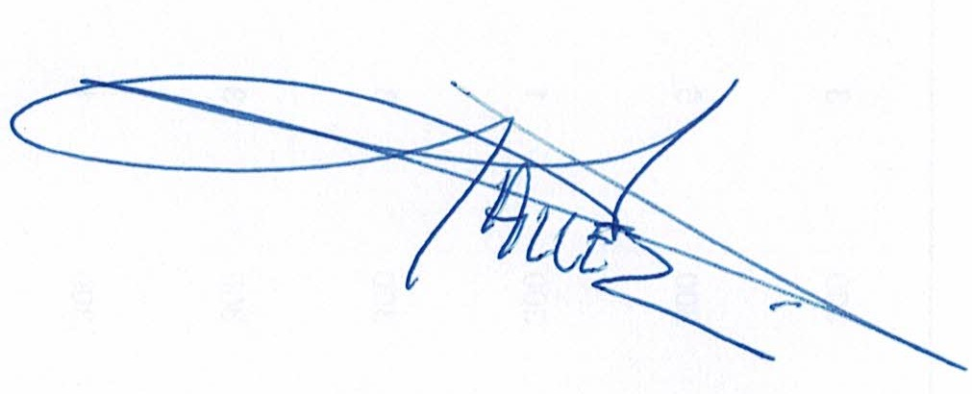
Name and Function: Alex Gallez/Sales
Signature: _______________________

